Online supplement to manuscript:

A Closed Circulation Langendorff Heart Perfusion Method for Cardiac Drug Screening

Carole Deflers1#, Rosa DOÑATE Puertas1#, Patrick Lechêne1, Philippe Mateo2, Florence Lefebvre1, Rodolphe Fischmeister1, Guillaume Pidoux1

#*These authors contributed equally to this work*

1Université Paris-Saclay, INSERM, Signaling and Cardiovascular Pathophysiology, Orsay, France

2Physics for Medicine Paris, Inserm, ESPCI PSL Paris, CNRS, Paris, France

**Supplementary methods**

Materials and equipment used in this protocol are listed in Supplemental Table 1.

**Air bubble trap**

A bubble trap must be integrated into the perfusion system to prevent air bubbles-mediated cardiac injury. The air bubble trap should be placed upstream of the perfused heart as shown in Supplemental Figure 1B. During the building process of a new air bubble trap, the lower part of a 2.5 ml syringe including the luer slip tip was cut off (Supplemental Figure 1C). Then, a silicone cap to close the orifice and seal the bubble trap was placed. In the silicone cap was inserted i/ a non-sharp needle collecting the perfusion solution into the bubble trap and ii/ a microprobe thermometer to record continuously the temperature of the perfusion solution delivered to the heart (Supplemental Figure 1C).

**Left ventricular pressure balloon**

A water-filled latex balloon catheter was inserted in the left ventricular cavity to measure the left ventricular isovolumetric pressure. The first step for the construction of a balloon is to fill it with a degassed water-ethanol mixture (95/5%) using a syringe. The solution should be previously degassed by a vacuum chamber as the presence of gases in the mixture would be detrimental to maintaining the accuracy of the pressure recording. A filled catheter with the degassed water-ethanol mixture was inserted inside the balloon and ligate twice with the surgical 3-0 silk (Supplemental Figure 1D). Then, the balloon catheter was connected to the perfusion system. A pressure of 80-100 mmHg via a micrometer syringe was applied to evaluate the presence of leaks from the ligating site or the balloon (Supplemental Figure 1E). A maintained pressure for 10 min indicates the absence of leaks. However, a variation of pressure requires starting from the beginning again. The balloon catheter should be stored for at most three weeks submerged in water at room temperature, in the absence of imposed pressure, and protected from light to preserve its elasticity and shape.

**Solution preparation**

Krebs-Henseleit buffer (KHB) and cannulation buffer should be extemporaneously prepared with ddH2O according to Supplemental Table 2 and can only be stored for 24 h at 4 °C. Milli-Q® water with a resistivity of 18.2 MΩ.cm is highly recommended. Both buffers need to be filtered through a 0.8 µm filter before use. The KHB is a physiological salt solution mimicking the extracellular environment of ions and nutrients. The KHB recipe can be replaced by another buffer containing 20 mM HEPES and 2 mM sodium pyruvate (pH 7.4) rather than 25 mM NaHCO3, and oxygenated with 100 % O2.

Isoproterenol (Iso) (*i.e.*, non-selective β-adrenergic receptor agonist) and propranolol hydrochloride (*i.e.*, non-selective β-blocker) are used in the pharmacological section of this protocol. Iso is heavily susceptible to oxidation (pH-, photo- and metal-catalyzed), thus it was resuspended with ascorbic acid to a final concentration of a 10-2M stock solution. Store aliquots at -20 °C and avoid multiple thaw/freeze cycles. Propranolol hydrochloridewasextemporaneously diluted with ethanol 96 % at 10 mg/ml. We have to be very careful when handling these products. Propranolol is harmful if swallowed. It is recommended to avoid the formation of dust and aerosols. Iso causes skin and eye irritation. It is advisable to wear gloves, eye protection, and a long-sleeved lab coat to avoid contact with skin and eyes.

**Setup calibration**

The experiment was performed at room temperature (*i.e.*, 20  °C) to avoid temperature variation affecting myocardial contractility and heart rate [1,2]. After logging in to IOX software, the water jacket bath, the microprobe thermometer, and the two pressure transducer amplifiers were switched on. Before starting up the setup, it is necessary to calibrate the pressure transducers (*i.e.*, aortic and left ventricular) that are connected to amplifiers and the microprobe thermometer. On the one hand, both pressure transducers were calibrated one after the other. Therefore, the connected catheter to the pressure transducer was filled with ultrapure water (ddH2O) without any air bubbles. After checking that the acquisition software detected the signal, the catheter was opened to atmospheric pressure. At this point, the basal pressure level indicated zero mmHg. If this is not the case, it is necessary to adjust it in the calibration menu of the amplifier. A handpump manometer was then connected to a pressure transducer and 100 mmHg was imposed. Pressure consistency between the imposed pressure and the one recorded by the software is mandatory. If not the case, it is possible to adjust it in the calibration menu of the amplifier. On the other hand, the microprobe thermometer was placed in a 37 °C water bath. The temperature in the acquisition software was checked and adjusted if necessary using the calibration menu of the thermometer.

**Step-by-step method details**

Perfusion system preparation

**Timing: 30 min**

Start the perfusion system off using a physiologic salt solution at 37 °C and a pH of 7.4 that mimics the internal environment of ions and nutrients.

**CRITICAL:** Pre-warm and oxygenate the perfusion solutions with carbogen (95 % O2; 5 % CO2) 20 min before heart perfusion to ensure pH stability.

1. Warm up the water jacket bath to maintain the temperature of the circulating perfusion solution at 37 °C.
2. Switch on the peristaltic pump (Figure 1A) at a maximum flow rate.
3. Rinse the system with sterilized ddH20 for 20 min in open circulation.
4. Remove air bubbles in circulating pipes by tapping gently on the pipes.
5. Adjust the constant-flow rate of the first peristaltic pump at 10 ml/min.
6. Place the air bubble trap, including the microprobe thermometer, as shown in Supplemental Figure 1C. The air bubble trap ambushed putative leftover bubbles. Keep the temperature of the circulating perfusion solution at 37 °C. If necessary, adjust the water bath temperature.
7. Turn on the carbogen (95 % O2; 5 % CO2) (Figure 1A) to oxygenate the KHB solution used for perfusion and stabilize the pH of the solution. The perfusion solution must be continuously heated (37 °C) in the water bath and oxygenated with carbogen (containing CO2) to maintain the pH stability.
8. Fill up the Langendorff apparatus, including circulating pipes, and into the container with oxygenated KHB solution (Figure 1A).
9. Turn on the second peristaltic pump (Figure 1A) to keep the glass container full of the KHB solution.

**CRITICAL:** Keep your perfusion system free of air bubbles all the time.

Anesthesia, excision of the heart, and cannulation of the aorta

**Timing: 15 min**

Deep anesthesia in rats by injection of barbiturates, together with administration of an anticoagulant. It is then possible to proceed with the surgical harvesting of the heart, and subsequently cannulation of the aorta.

1. Oxygenate chilled cannulation buffer solution.
2. Prepare sterilized surgical tools (forceps and scissors).
3. Weight the animal. Generally, a 200–350 g rat is 6-8 weeks old.
4. Prepare the cannulation system (see Supplemental Figure 1A).
   1. Fill a 60 mm petri dish with pre-cold oxygenated cannulation buffer solution.
   2. Aspirate an appropriate 2.5 ml volume of a cannulation buffer solution using a 2.5 ml syringe, which connects to the cannula, while avoiding introducing air bubbles.
   3. Fix the syringe on the stand, and optimize the height to adjust the end of the cannula inside the 60 mm petri dish.
   4. Tie surgical silk to the connecting site of the syringe for tying the aorta.
5. Heparinize rat with sodium heparin intraperitoneally injected at 1000 U/kg 20 min before sacrifice to prevent thrombus formation and heart coronary embolism during heart excision.
6. After 15 min, anesthetize the rat with Euthasol (pentobarbital sodium) intraperitoneally injected at 80 mg/kg.
7. Excision of the heart.
8. Fill a small beaker (50 ml) with a pre-cold oxygenated cannulation buffer solution.
9. 5 min after injection and before continuing, check if the rat is in deep sleep and the pedal pain withdrawal reflex disappears.
10. Place the rat in the supine position. Spray the chest and upper abdomen with 75 % ethanol.
11. Make a skin incision at the xyphoid-sternum, and continue then through the ribs on both sides to create a clamshell thoracotomy, which provides a complete exposure of the thoracic cavity (heart, mediastinum, and lungs).
12. Quickly remove the heart, including the thymus and intact aortic arch, within a maximum of 3 min after the first incision to avoid cardiac damage (*i.e*., ischemic injury).
13. Put the heart into the small beaker with ice-cold oxygenated cannulation buffer solution to stop the heart from beating temporarily. Gently press 2–3 times the heart against the beaker wall to rinse the blood. Clean up the aortic root (leave 3–5 mm length of the aorta), and remove if necessary other tissues (the heart is sometimes removed along with some lung tissues to save time) to ensure proper cannulation.
14. Cannulation of the aorta (Supplemental Figure 1A).
15. Transfer the heart to the 60 mm petri dish with ice-cold oxygenated cannulation buffer solution.
16. Appropriately, mount the ascending aorta on the aortic cannula. The cannula is connected to the first reservoir (Figure 1A) containing an oxygenated perfusion solution.

**Note**: Be careful not to insert the cannula deep into the aorta as this could entail mechanical damage to the aortic valve leaflets and causes inefficient perfusion. For rat hearts, a 21-gauge luer-lock needle is employed as a cannula.

1. Ligate twice with the prepared surgical silk to secure the ligating site.
2. Slowly inject cannulation buffer solution into the aorta to exclude blood from the coronary artery and the heart cavity.
3. Quickly connect the heart to the Langendorff apparatus. Carefully mount the aortic cannula with the heart on the setup and fix it properly to avoid introducing air bubbles. Immediately the heart recovers the contractile function.
4. Pierce the apex of the heart with a needle (18 gauge) to avoid overpressure.
5. Suspend the heart from its aortic cannula in a hot glass bucket (Figure 1A) to maintain a correct and constant temperature (37 °C) (Figure 1A).

**CRITICAL:** The total time from the heart is removed to mounted and perfused on the Langendorff system should be minimized to ischemic preconditioning of the heart. We recommend the shortest time possible, about 5 minutes. During this time, the perfusate must be dripping to establish rapid fluid communication and minimize the risk of air being introduced into the coronary vasculature producing an air embolus.

Retrograde heart perfusion and acquisition

**Timing: ≤ 1 h**

Rat heart is perfused via the aorta with a nutrient-rich oxygenated solution in a constant-flow allowing the heart to work for several hours after excision. The perfusion solution flows retrograde through the aorta, opposite to the normal physiological flow, so the aortic valve is closed under pressure. The perfusion solution then passes through the coronary vascular bed. The perfusion system connected to the IOX software allows the evaluation and recording of multiple cardiac hemodynamic parameters.

1. Perfuse oxygenated KHB solution at a constant-flow rate (10 ml/min). At the end of the perfusion, the solution is thrown away.
2. A catheter is placed just proximal to the aorta and connected to a pressure transducer to measure the coronary perfusion pressure (CPP). Wait around 10 min to stabilize the function of the heart, and start then to register the basal CPP (approximately 80 mmHg for a rat of 300 g) for 20 min
3. The balloon catheter is connected to a pressure transducer to measure developed left ventricular pressure (dLVP) and left ventricular end-diastolic pressure (LVEDP). The transducer and heart were positioned at the same height to ensure pressure accuracy.
4. Left ventricular pressure balloon insertion:
5. Hold the heart with your fingers and gently insert the filled balloon into the left ventricle of the heart (just above the apex wall), accessed by removing the left atrial appendage, and passing through the mitral valve. Be careful not to pull on the aorta during this process.

**Note**: If it is necessary to reduce the volume of the balloon, decrease the balloon pressure with the micrometer syringe.

1. Fix the balloon catheter to the setup with a tape to avoid bias in the pressure recording due to movements during each cardiac contraction.
2. After several minutes, increase the balloon pressure from 10 µL to 10 µL with the micrometer syringe. Check the stabilization of the dLVP before each increase. The increase should stop when the dLVP no longer increases, indicating that the balloon pressure completely encompasses the left ventricular cavity. The recording of the parameters in the basal situation with the balloon follows.
3. Check the LVEDP, it should be stable throughout the experiment between 0-10 mmHg. A continuous increase in LVEDP indicates cardiac damage, while a decrease suggests a leak in the pressure balloon.

**Note**: Any movement of the perfusion system during the recording procedure should affect the precision of the measure.

Pharmacological applications

**Timing: 1h 5 min**

Evaluation of the effects of different drugs on the heart. Pharmacological applications of the perfusion system are quite varied, such as the investigation of positive/negative inotropic effects of putative drug candidates as well as arrhythmogenic or anti-arrhythmic effects, among others. The close-circulation perfusion system takes advantage to reduce the cost of the experiment.

1. After heart stabilization of the heart, administer the various drugs (e.g., propranolol) via the circulating perfusion solution.
2. Dilute the drug in the oxygenated KHB solution at the use concentration.
3. Spill the drug solution into the second container (see Figure 1A).
4. Switch to perfuse the drug solution from the second container. Close the perfusion circuit by placing the pipe after the heart in the second container to re-use the perfusion solution instead of discarding it.
5. Set a 1h timer.
6. β-adrenergic stimulation of cardiac muscle administrating Iso for 3 min.

**Optional:** It is possible to use a syringe driver to deliver the medication, as long as the concentration of the drug reaching the heart is appropriately adjusted.

End of acquisition

**Timing: 15 min**

Thorough flushing of the setup after use to remove residues from the plastic and glassware after each day’s experiments.

1. Stop the recording.
2. Deflate the balloon to the initial position, take it out of the heart, and hold it submerged in water.
3. Remove the heart from the cannula. At this point, the heart can be used for further analyses (e.g., immunoblot, RT-qPCR, imaging).
4. Remove the air bubble trap.
5. Clean the system with the first peristaltic pump (Figure 1A) to remove adhering molecules (e.g., organic molecules) from the plastic tubings and glass reservoirs. Fill up the perfusion apparatus, including circulating pipes, with:
6. sterilized ddH2O.
7. 70% ethanol.
8. 2 times with sterilized ddH2O.
9. Empty the system after the washes.
10. Switch off all the equipment (water bath, the microprobe thermometer, peristaltic pumps, and two pressure transducer amplifiers).
11. Close the IOX software and shut down the computer.

**Supplemental Data**

**Supplementary Table 1.**

List of materials and equipment used in the experiment.

|  |  |  |
| --- | --- | --- |
| REAGENT or RESOURCE | SOURCE | IDENTIFIER |
| Chemicals | | |
| NaCl | Euromedex | Cat#1112-A |
| KCl | Euromedex | Cat#P017-B |
| MgSO4 7H2O | Euromedex | Cat#P027-A |
| CaCl2 2H2O | Sigma-Aldrich | Cat#C3881-500G |
| NaHCO3 | Euromedex | Cat#6885-1 |
| KH2PO4 | Sigma-Aldrich | Cat#P0662-1KG |
| Sodium acetate | Sigma-Aldrich | Cat#S8750 |
| D+Glucose anhydrous | Euromedex | Cat#UG3050 |
| D-Mannitol(g) | Sigma-Aldrich | Cat#M4125 |
| Isoproterenol | Sigma-Aldrich | Cat#I6504-1G |
| Ascorbic acid | Sigma-Aldrich | Cat#A5960-25G |
| Propranolol hydrochloride | Sigma-Aldrich | Cat#P0884-1G |
| EtOH 96% |  |  |
| Euthasol vet. (pentobarbital sodium: 400 mg/ml) | Dechra |  |
| Sodium Heparin | Sigma | H3393 |
| Experimental models: Organisms/strains | | |
| Rat: RjHan:WI: Tyrc/Tyrc | Janvier Labs | Wistar rat |
| Software | | |
| IOX V1.8 | Emka Technologies | https://www.emkatech.com/iox2-software/ |
| Other | | |
| Water bath | Julabo MD |  |
| Amplifier | Homemade |  |
| Pressure transducer | Ohmeda | Statham gauge |
| Microprobe thermometer | Physitemp | BAT-12 |
| Vacuum chamber | Homemade |  |
| Latex balloon | Emka Technologies | Cat#ISOH_BALLOON_S3_3x7 |
| Manometer linked to a pump |  |  |
| Surgical silk 3.0 bis | Ethicon | Cat#F4204 |
| Membrane filters (0.8 µm) | Whatman | Cat#10400912 |
| Peristaltic pump | Ismatec | Cat#ISMATEC-IPS-12 |
| Microporous waterproof tape | 3M | Cat#MI512 |
| Micrometer Syringe | Gilmont | Cat#GS-1100 |
| Circulating pipes, catheter, syringe |  |  |
| Forceps and scissors |  |  |
| 60 mm petri dish, beaker |  |  |

**Supplementary Table 2.**

Composition of the buffers.

1. **KHB (pH 7.4), 1 L**

|  |  |  |
| --- | --- | --- |
| **Reagent** | **Final concentration (mM)** | **Amount** |
| NaCl [947.6 mM] | 116 | 122 ml |
| KCl [190.5 mM] | 4.7 | 25 ml |
| MgSO4 [47.5 mM] | 1.2 | 25 ml |
| CaCl2 [100 mM] | 1.25 | 13 ml |
| NaHCO3 [200 mM] | 25 | 125 ml |
| KH2PO4 [47.4 mM] | 1.2 | 25 ml |
| Sodium acetate | 2 | 0.22 g |
| D-glucose | 11 | 1.98 g |
| Mannitol | 1.1 | 0.2 g |
| ddH2O | n/a | q.s. for 1 l |
| **Total** | **n/a** | 1. **l** |

1. **Cannulation buffer (pH 7.4), 100 ml**

|  |  |  |
| --- | --- | --- |
| **Reagent** | **Final concentration (mM)** | **Amount** |
| NaCl [947.6 mM] | 118 | 12.5 ml |
| KCl [190.5 mM] | 4.7 | 2.47 ml |
| MgSO4 [47.5 mM] | 1.2 | 2.53 ml |
| NaHCO3 [200 mM] | 25 | 12.5 ml |
| KH2PO4 [47.4 mM] | 1.2 | 2.5 ml |
| D-glucose | 15 | 0.27 g |
| ddH2O | n/a | q.s. for 100 ml |
| **Total** | **n/a** | **100 ml** |

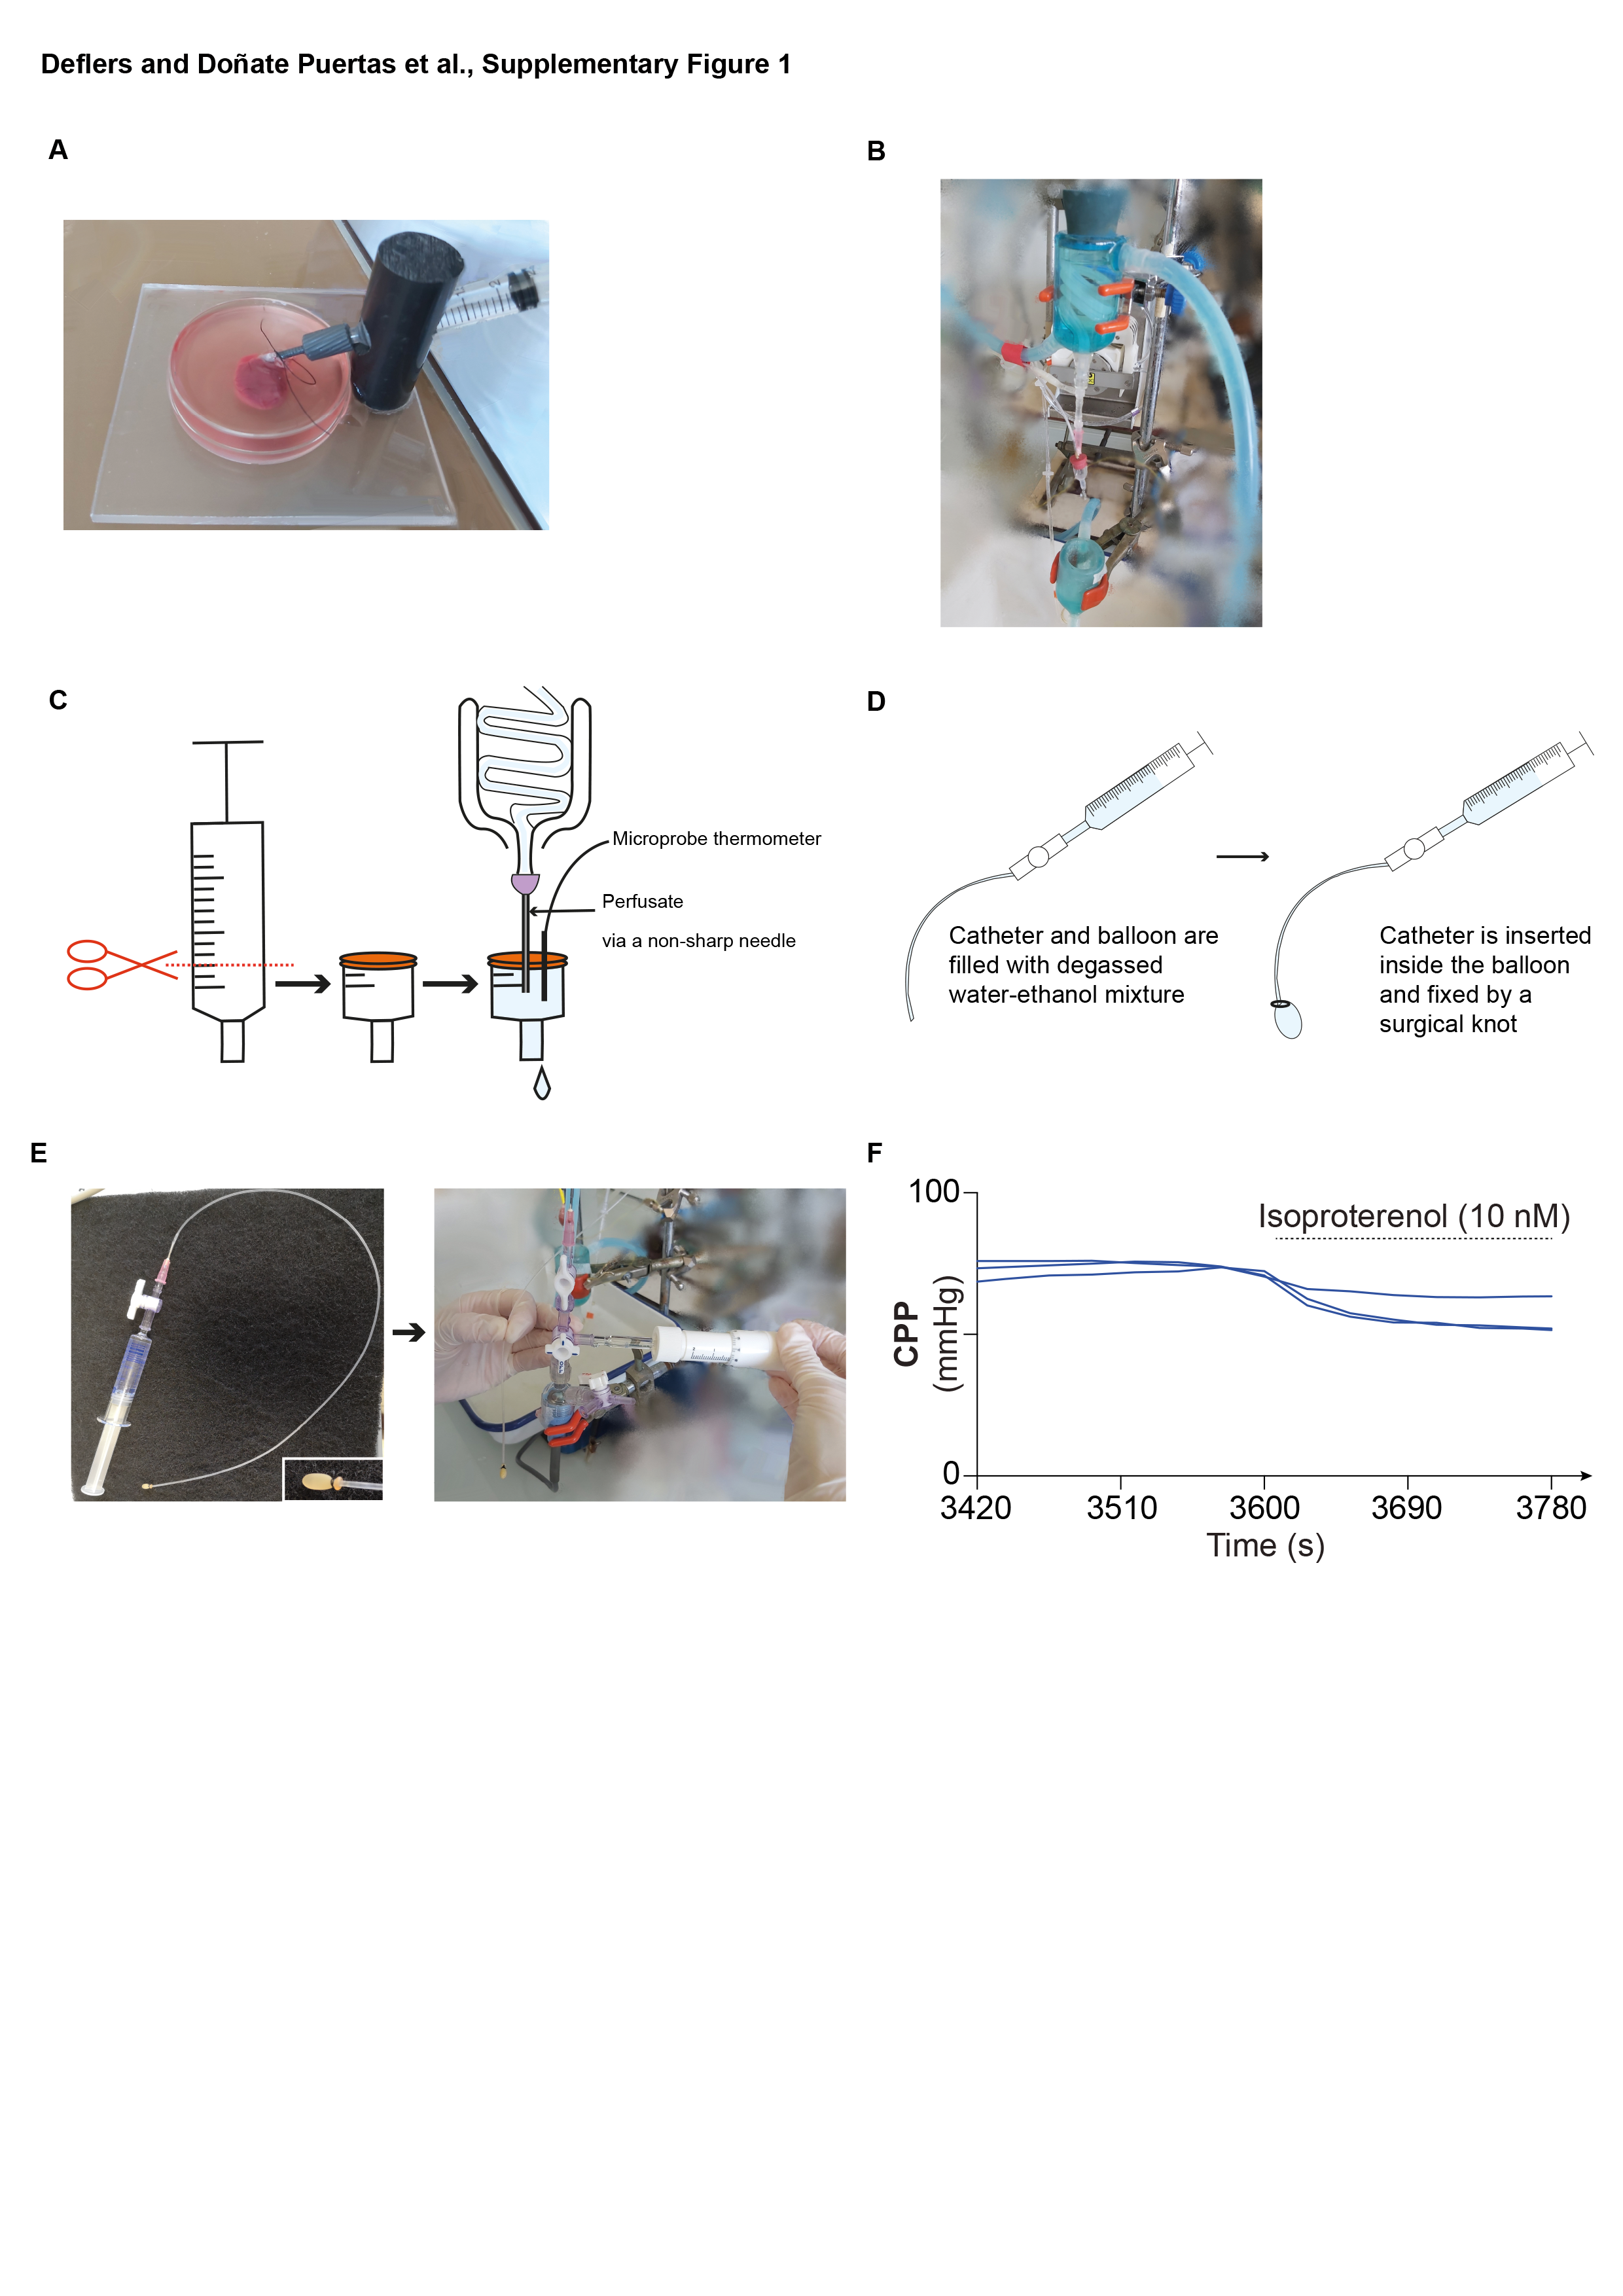**Supplemental Figure 1. Air bubble trap prevents air bubbles-mediated cardiac injury. (A)** Cannula system. **(B)** Place where the air bubble trap is placed in the perfusion system. **(C)** Steps to follow to build an air bubble trap. **(D)** Steps for constructing a left ventricular pressure measurement balloon. **(E)** Adjustment after balloon insertion into the left ventricular cavity. **(F)** Time course traces of the coronary perfusion pressure (CPP) from perfused rat hearts in closed (dark blue) circulation before or after isoproterenol infusion (10 nM).

**References**

1. Sutherland FJ, Shattock MJ, Baker KE, Hearse DJ. Mouse isolated perfused heart: characteristics and cautions. Clin Exp Pharmacol Physiol 2003;30:867-878.

2. Fukunami M, Hearse DJ. The inotropic consequences of cooling: studies in the isolated rat heart. Heart Vessels 1989;5:1-9.