EEA/Norway Grant CZ 0135
“Monitoring of chlorine in the forest ecosystem – its cycling and effects”
Meeting notation Aas 7-10.6.2009

Matucha, Clarke, Forczek, Lachmanová

- What happened from our last meeting in March 09 – summarizing advance (program February – June)
  - Chlorination experiments started
Low MW compounds are present in the 1st extract of chlorination experiments
No LMW compounds are in the HA extract
Želivka FH soil has about 30% of the chlorination activity (only 30-40 nCi ³⁶Cl-chlorohumus from 10 µCi and 10g soil obtained) than Baně FH soil
  - Preparation of labeled compounds
Literary research of possibilities
³⁶Cl isotopic exchange -benzyl chloride not stable in aqueous solution
Reverse phase radio-HPLC suitable for stable ³⁶Cl-compounds
  - Fractionation of humic substances by gel filtration (Size Exclusion Chromatogpraphy)
Sephadex G-25, G-50, G-100 columns were tested, Bio-Rad Bio-Gel P-2, P-4 columns are also possible
Model experiments with added ³⁶Cl-chloride show the elution of free Cl⁻ on Sephadex columns (closely before LMW compounds)
Various, but similar fractionation of 3 soil extract fractions
  - Sampling from Czech monitoring plots
12 plots sampled once (water samples taken for AOX and CHCl₃ analyses)
3 soil samples (together with their HAs) for ¹⁴C analysis from Želivka
  - Microbiological analyses
the highest microbial DNA concentration is in the FH horizon, then it decreases
  - Web page started
http://www.biomed.cas.cz/ueb/izotopy/EHPNorsko/

- Discussion on Birkenes soil sampling
  - Birkenes soil profile description
RealityHeightModel
L+F+H horizon10-15 cm
(9 cm avg.)Hor 1E horizon10 cmHor 2B+BC horizon42 cmHor 3
  - Forest description
Birkenes: natural forest, a little mixed with broadleaved spp. and Scots pine, podzol soil
Baně, Želivka: planted forest, climactic vegetation of normal succession would be a mixed forest
  - Sampling for ¹⁴C analysis
Not much varying, no need to take, only for horizon E
Old samples are stored in dried form – no need to take fresh ones
  - Sampling for analysis of water
Must be sterile filtered (formerly with 0.45 µm, now 0.2 µm filter)
Pooled for 3 month after filtering, then send to Norway for ¹⁴C analysis
In Birkenes 9.6.2009: soil water and run-off water samples
Preparation and recovering of soil lysimeters at 15, 40 cm (suction lysimeters with pumps and zero tension lysimeters), throughfall samplers
Bulk precipitation sampling at the Norwegian Meteorological Institute site (just downhill)

- Administration
  - Preparation of the 1st report, to be handed over (beginning July)
List of bills
Account statement
Salaries, contracts
Work evidence lists monthly

- Theoretical discussion of the project
  - Chlorinated compounds production in plants
Papers of Engvild, Myneni, Harper, Winterton
  - AOX compounds
in needles: CHCl₃, TCA, other Cl-substances
in soil: LMW, HMW compounds, Cl-humic acids
  - Soil fractionation
Leenheer J.A. (1981) EST 15, 578-587.
F+H horizon: high concentration of carbon, high microbial activity, high concentration of Cl-humus, most HA present in the soil
  - Hydrophobic/hydrophilic DOC sample fractionation
Why is it in the model?
Determination by XAD-8 columns
Suggestion to modify the model to use hydrolysable/not hydrolysable compounds in it instead of hydrophobic/hydrophilic
Suggestion to modify the model to use soil fractions (isolated HA, FA)

- Birkenes soil and water sampling (9.6.2009)
  - Cambisol, podzol and histosol (bog) are present
  - Cl⁻ deposition: 100 kg/ha/year (7-15 in the CR)
  - Frequent plant species present at the site: Picea abies, Dicranum spp., Vaccinium myrtillus, Vaccinium vitis-idaea, Pleurozium schreberi, Rhytidiadelphus loreu, Sphagnum spp., Deschampsia flexuosa, Betula pubescens (according to ICP Forests 2003)
  - Less frequent species present at the site: Lycopodium (plavuň), Polytrichum spp. (ploník), Pinus sylvestris, Sorbus aucuparia, Barbilophozia spp., Hylocomium splendens, Maianthemum bifolium, Plagiothecium undulatum, Cladonia spp., Ptilium crista-castrensis, Cornus suecica
  - Map of Birkenes monitoring plot (1 – former PROTOS sampling site, 2 – ICP level II sampling plot, stream water – NIVA and NVE measurements, meteorology – NILU measurements)
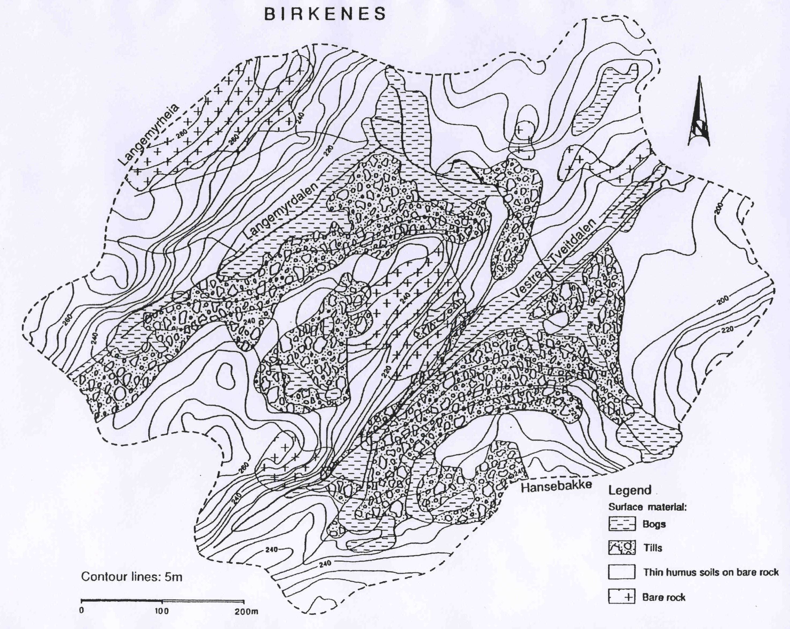
2
1

